Workshop Report

April 30th, 2020.Translated from original french
“Change through Culture”
Organized by
Grandmother Project - Change through Culture
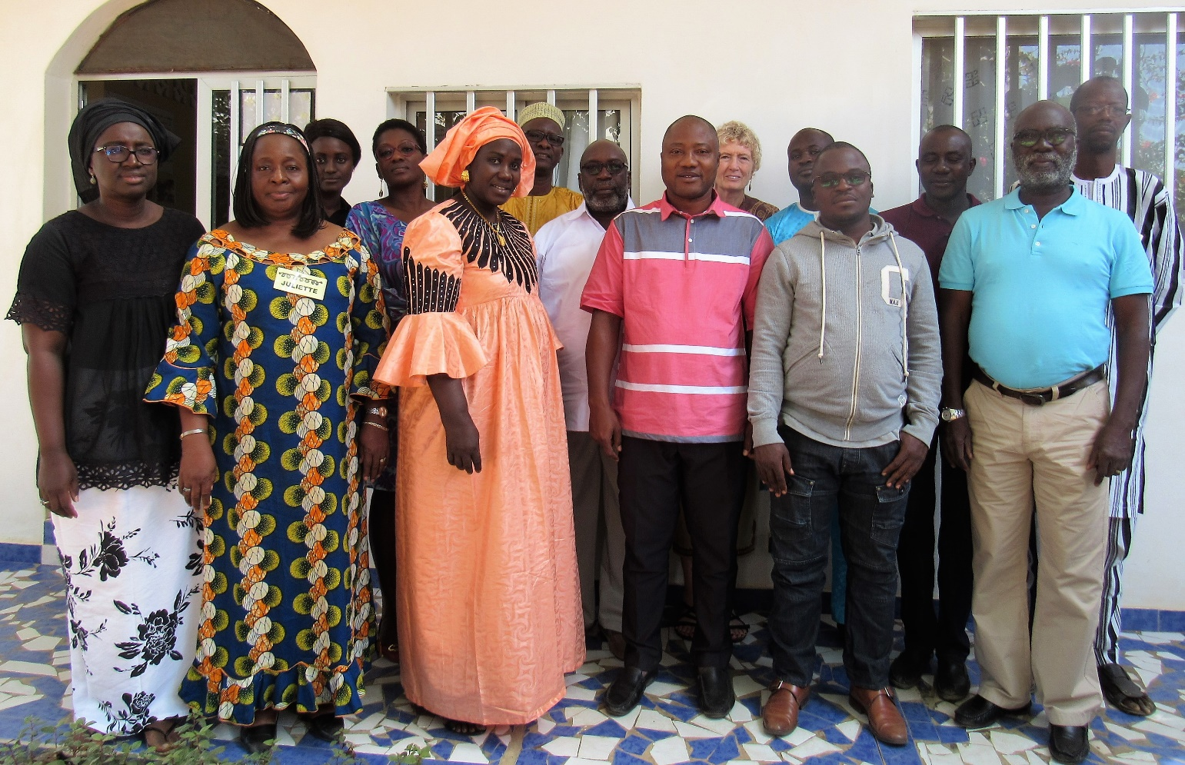

Mbour, Senegal

16 to 20 December 2019
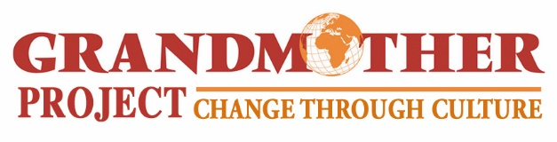
www.grandmotherproject.org

Reflections of workshop participants

"When preparing projects and programs in a given locality, culture must be considered first and foremost. With this perspective, it is important, at the risk of going astray, to involve the right people, namely elders. For example, grandmothers. ”
Charles Biagui, National Secretary for Catholic Education, Senegal

“Grandmothers play an essential role. Any development project needs to enhance the cultural values and traditions of communities in order to perpetuate good practices.”
N’DRI Pascal, PNDEP, Ivory Coast

"All the efforts we make in the implementation of development projects have mixed results because we do not include some actors who have a great influence in the communities.”
Karidja Kone, PNMDPE, Ivory Coast

"People, as individuals, do not make decisions or changes on their own. They are influenced by social norms, the informal and hidden networks of influence that revolve around them. To get them to change, you have to work on the whole system.”
Alioune Ndiaye, School director BOUKHOU, Senegal

“A communication strategy that involves the community actors can create a real synergy around a given problem."
André Niane, Center for Pedagogical Training-Catholic Education, Senegal

"Lasting change in a given community requires not only the elders, the guarantors of social norms, but also leaders, who must play a decisive role in the process of rejecting or adapting innovations."
Jean Baptiste Boligan, PNMDPE, Côte D’Ivoire

Pictures from the workshop
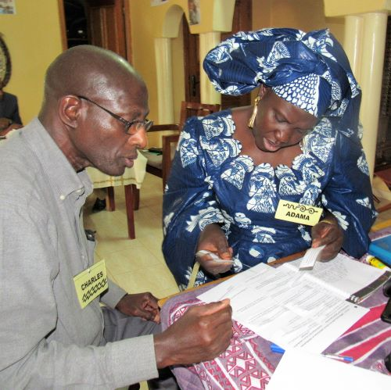 | 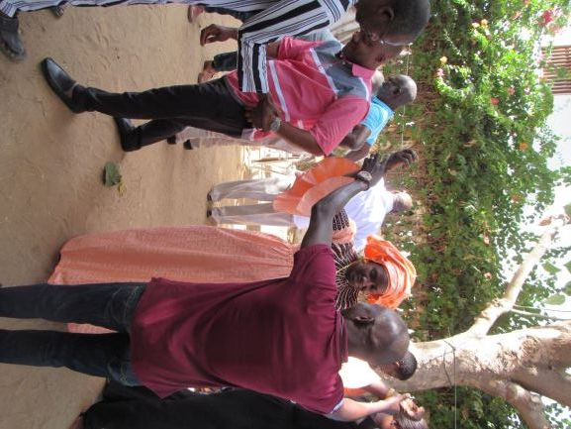
Group work | Modeling game
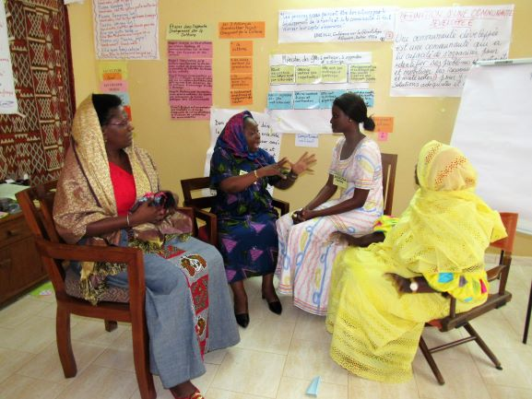 | 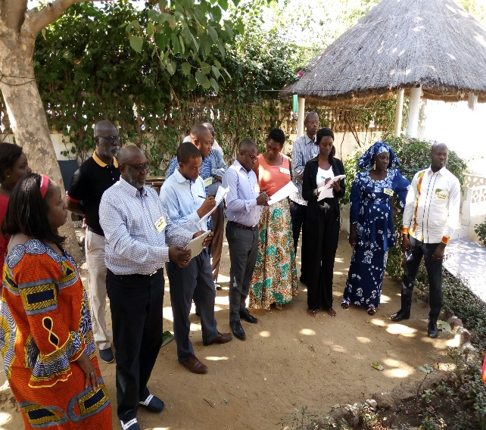
Role-playing exercice | Feedback of group work
Summary
Introduction: 5
Purpose of the Change Through Culture Workshop 5
The objectives of the workshop 6
Organization of the workshops: 7
Summary of sessions 8
The evaluation of the workshop by the participants 22
List of participants to the Change through Culture Workshop - 16 to 21 December 2019- 23

Introduction:
This report on the “Change through Culture” workshop organized by Grandmother Project from the 16th -20th December 2019 in Mbour, Senegal, presents: the workshop goals and objectives; an overview of the workshop content; feedback from participants on topics addressed; and the results of the workshop evaluation completed by participants.
Grandmother Project (GMP) – Change through the Culture is an American and Senegalese NGO that develops community-based approaches to reinforce positive cultural values and roles, placing value on community knowledge and experience and building the capacity of communities to analyze problems and decide for themselves how to tackle them. GMP's work is based on five pillars.

The pillars of Grandmother Project - Change Through Culture
- The inclusion of culture in any development program;
- Recognition and effective involvement of elders (grandmothers and grandfathers) in community programs;
- Reinforcement of communication between the three generations and both genders;
- The use of communication approaches based on dialogue and consensus building; and
- Reinforcement of confidence and knowledge of leaders of all generations.

Grandmother Project has developed « the Change through culture approach », which builds upon succesful interventions that included grandmomothers in: education, nutritionand community health Programs in Senegal, Mali, Mauritiania, Djibouti, Laos and other developing countries.
In each of the interventions in the countries mentioned, the involvement of grandmothers has contributed to increasing their communities' confidence in their knowledge and experience and to improving the results of the programs.

Purpose of the Change Through Culture Workshop
- To stimulate participants' reflection on key aspects of culture in community-based programs.
- To promote sustainable changes in norms and practices related to the well-being of women and children.

The objectives of the workshop

Objective 1: Discuss the place of culture in community life and in development programs.
Objective 2: Discuss the role of seniors in African societies and their place in development programs.
Objective 3: Identify the role of grandmothers in families and communities and their involvement in development programs for women and children.
Objective 4: Identify the factors that explain why grandmothers are not involved in development programs for women and children.
Objective 5: Identify the differences between individualistic and collectivist societies and their inclusion in development programs in Africa.
Objective 6: Discuss the influence of culture on social norms and on individual behavior in collectivist societies.
Objective 7: Discuss the difference between a "linear" approach and a "systemic" approach to promote change in communities.
Objective 8: Discuss the three factors that contribute to the success of community programs.
Objective 9: Discuss the unexpected negative effects of many development programs.
Objective 10: Define "a developed community".
Objective 11: Learn from the results of the Change Through Culture approach in the areas of health protection, education and social infrastructure.
Objective 12: Present GMP’s Change through Culture approach from the community perspective.
Objective 13: Introduce the five steps of the Culture Change approach to promote the well-being of women and children.
Objective 14: Discuss the rapid study approach to analyze the roles and influences of family and community actors.
Objective 15: Discuss the importance of valuing the role of grandmothers in promoting positive change.
Objective 16: Discuss two different communication approaches that can be used with communities.
Objective 17: Analyze the relevance of the change model of “knowledge -attitudes-practices” often used in collectivist societies.
Objective 18: Discuss the communication approach that promotes dialogue and consensus for lasting changes in social norms.
Objective 19: Discuss principles of adult education that promote community engagement and change.
Objective 20: Discuss communication tools based on dialogue and critical reflection.
Objective 21: Discuss the communication and influence dynamics between older and younger women in the community.
Objective 22: Share the Grandmothers Under-the-Tree Training Experience
Objective 23: Discuss the influence of formal and informal leaders in the process of changing social norms.
Objective 24: Discuss collaboration with community leaders.
Objective 25: Discuss key aspects of the monitoring, evaluation and lifelong learning.
Objective 26: Identify the attitudes and skills of development workers who promote community development and positive sustainable change.
Objective 27: Identify the factors that contribute to the ownership and sustainability of the programs.
Objective 28: Reflect on the application of the elements of the Culture Change approach in the programs of those participating to the workshop.

Participants:
The workshop participants come from Senegal and the Ivory Coast. The majority work in non-governmental organizations that implement nutrition/health, education and/or child protection programs.
GMP was able to invite a student and two teacher-researchers from the School of Applied Economics (ESEA) at the University of Dakar, a school director from a village in Mbour, the Coordinator of the National Office of Catholic Education in Senegal (ONECS), the director of the Catholic teacher training center in Senegal, and the departmental coordinator of schooling for girls in Vélingara thanks to the support of the English organization ViiV Healthcare.

Organization of the workshops:
- The theme of the workshop
The content of the workshop program is structured around twenty-seven (27) themes related to the 28 objectives presented above.
- The pedagogical approach used during the workshop
In the workshop, a participatory adult learning methodology was used which called on participants to:
  - reflect on their own attitudes and experiences in community programs;
  - discuss the concepts that support a partnership approach with GMs;
  - reflect upon the possibility of using elements of this approach in their respective programs;
The presentation and discussion of the approach developed by GMP was conducted through a series of participatory learning activities, namely: individual exercises, in pairs, in small groups or with all participants, the analysis of cases, mini-presentations, role-plays and simulations.
All learning activities were interactive.

Summary of sessions
The content of the different sessions is briefly described below. Findings and comments from some participants related to each theme discussed are presented below.
The onion model: the influence of culture on the individual

1. The place of culture in the life of communities and in development programs
In a group exercise, participants discussed the importance of culture in community life and in development programs. They reflected on three quotes that discuss the importance of culture in African societies. Each group drew conclusions about the extent to which development programs in their countries take culture into account.
During this discussion, the "onion model" was presented (see box). This diagram shows the central influence of culture on individuals in relation to all aspects of life.

Participants’conclusion: Culture is the foundation of development; therefore taking culture into account is fundamental for the success of development projects. Unfortunately, we know that most development programs do not consider culture enough.

“Any development project needs to enhance cultural values and traditions in order to perpetuate good practices.”
N’DRI Pascal, PNDEP, Ivory Coast

"Reflecting on the nature of our culture has allowed me to conclude that we must take into account our cultural values, essentially our cultural realities at all stages of a project if we want it to be sustainable and successful.”
Doumbia Vamajan: ASAPSU Focal Point, Cote d´Ivoire

2. The role of elders in African societies and in development programs
This session revolved around the analysis of several quotes on the role of elders in collectivist, non-Western societies, and more particularly, in African societies.
Participants’ conclusion: To succeed in their mission, development programs must rely on elders, who are an important resource. Without their involvement, projects and programs will find it difficult to achieve their objectives.
Doumbia Vamajan: ASAPSU Focal Point, Ivory Coast
Doumbia Vamajan: ASAPSU Focal Point, Cote d´Ivoire.

"Elders provide continuity in society and they have experience, knowledge, authority and influence. To ignore these elders means impeding positive influence to people in our communities.”
Fatou Dème, ESEA,Senegal

3. The role of grandmothers in families and communities and their involvement in development programs for women and children
In a working group exercise, participants reflected on the roles played by grandmothers in the communities they work with. Each group created a diagram that showed the different roles they play in the family and in the community, such as: counsellor, mediator, protector and resource person for women and men.
Participants’ conclusion: Grandmothers are a valuable resource in all areas/sectors (health, nutrition, child protection, etc.), and development programs must value them. Programs covering these various areas would benefit greatly by involving these valuable people. That way, positive results in their interventions could be obtained. The role of grandmothers is similar from one culture to another.

"Thinking about grandmothers was for me a very good opportunity to better appreciate their involvement in the implementation of sustainable development programs and projects. This must be a primary concern in African societies’ culture.»
Moussa Traore, Ivory Coast
“Grandmothers are important advisors in the fields of health, nutrition, education, etc. ; they possess knowledge, and are leading voices and social regulators.”
Adama Sarr, CDEP/SCOFI,Senegal

4. The factors that explain why grandmothers have little involvem t in development programs targeting women and children
Participants’ conclusion: Despite their know-how and expertise, most development programs do not involve grandmothers in those interventions that benefit women, children and adolescent girls. The predominant model in projects/programs often targets young women or adolescent girls. However, if we want to change practices in families and communities, we must involve the stepmothers/grandmothers or aunts – who are counsellors and assistants – in strategies that concern the lives of women and children.

In groups of three, participants brainstormed to list the different factors that explain the limited involvement of grandmothers in development programs for women and children. After analyzing various factors, participants concluded that these factors were mostly based on unfounded biases against them.

“Grandmothers are marginalized because of prejudices. Yet they have power and influence, and they play multisectoral roles through their activities."
Vamagan Doumbia, ASAPSU, Ivory Coast

5. Differences between individualist and collectivist societies and their inclusion in development programs in collectivist societies
In pairs, participants were asked to rank characteristics of both types of societies on a two-column chart. Participants also reflected on the types of societies in which the communities they work with live.

Participants’ conclusion: Most of the programs are designed and/or influenced by international organizations which, above all, have an individualist perception and aim to change individuals’ behavior. In collectivist societies, the individual is strongly influenced by the group; this makes it necessary to reflect on how to develop programs that take into account the characteristics of these African societies to promote collective changes in social norms.

“The programs implemented in southern countries reflect the individualist perception of great institutions’ experts of northern countries ".
Vamagan Doumbia, ASAPSU, Ivory Coast

6. Influence of culture on social norms and individual behavior in collectivist societies
For ten years, the term "social practices" has been used in health/nutrition, reproductive health and child protection programs (child marriage, female circumcision, etc.).
Several definitions are known, but UNICEF has proposed the following definition:
“Social norms are rules of conduct and patterns of behavior, prescribed by a community or a society. They are rooted in customs, traditions and value systems.”
Participants' conclusion: Culture has an influence on social norms which, in turn, have a direct influence on individuals’ behaviors. Any process of change in a collectivist society should therefore begin to change collective norms in order to achieve individual change.

"Behavioral changes are produced by social norms, which themselves are guided by cultural and community systems."
Jean Baptiste Boligan, PNMDPE, Ivory Coast

"To be effective and achieve change in behavior, programs need to identify social norms and the people who perpetuate them."
Fatou Dème, ESEA, Senegal

7. The difference between a linear approach and a systemic approach to problem analysis and program development.
In many community programs, the linear approach used target risk groups that are often referred to as "target groups." For example, in a program to reduce pregnancy, if a linear approach is used, it is the girls who are targeted. In this case, other categories of people, such as boys, grandmothers and mothers who may also have influence over these issues, would not be targeted.
In a small group exercise, participants made a "systemic" analysis of identifying the set of people who influence issues such as excision, breastfeeding and early marriage.
Participants' conclusion: In any system, elements are interrelated. There are influence and decision-making centers that define acceptable or unacceptable norms. To achieve lasting results, the important elements of this system must accept the change. According to this logic, it is essential to identify the most influential people and their influence networks.

"A systemic approach that identifies social norms that define what is acceptable or not is the safest way to build programs for the sustainable development of a community."
Moussa Traoré, PMNDPE, Ivory Coast

8. The three factors that contribute to the success of community programs

American researchers in community development analyzed many programs in the health, agriculture, education and child protection sectors. They identified three factors that contribute to program success. These are:
- characteristics of the community;
- characteristics of the approach adopted; and
- characteristics of development agents.
Participants discussed the importance of each.
Participants' conclusion: The development programs must focus on intervention strategies that take into account communities’ characteristics, use appropriate methodologies and determine appropriate behavior for health and development workers. No development program could succeed without seriously taking these three factors into account.

"The three factors that contribute to programs’ success are equally important. Development actors must balance them correctly if they want their projects and programs to be successful.
Karidja Kone, PNMDPE, Ivory Coast

9. The unexpected negative effects of many development programs
A research project entitled "The Time to Listen" was carried out in 20 countries with 6,000 interviewees in order to obtain their opinions on development programs.
The conclusions of the research were presented and deal with five key themes:
- Development programs have increased community dependency and passivity.
- Development workers do not have the time to build trust with communities.
- Programs do not take into account existing structures/leadership in communities.
- Agents have their own schedule and they are in a hurry to implement their activities.
- There is usually too much money in programs that needs to be spent too quickly.
Participants' conclusion: Development programs can produce unexpected and harmful effects. They can contribute in many ways to increasing the dependence and passivity of community members.

“Unexpected effects of development programs are a reality. In most development programs, beneficiaries’ real needs are not taken into account. Although financial resources are enormous, results do not follow, and often projects are not sustainable.”
Salif Baldé, ESEA, Senegal
"Instead of being a motivating factor in programs, free distribution of money to the populations ends up becoming a demotivating factor."
Mamadou Falilou Ba, ESEA, Senegal

10. Characteristics of a developed community
All development organizations and government institutions want communities to develop. But the question is: What is the concept of a developed community? As development agents working at the community level, it is important to define the characteristics of a developed community so that policies and programs explicitly aim to contribute to the realization of such communities.

Community Development Specialists propose this definition:
"In a developed community, the population leads a set of actions and
efforts to improve their living conditions. In these actions and
efforts, there is: the involvement of all social strata; committed leaders; a
good level of organization; the capacity for self-management and permanent consultation between leaders and other members of the community ."
Participants' conclusion: A developed community has the capacity to identify its problems and, through its leaders, to find its own strategies to solve them.

“People from outside the community cannot pretend to develop it. It is the communities’ awareness and commitment to challenges that are very important. "
André Niane, CFP- Catholic Education, Senegal

11. The results of the Change Through Culture approach in health, child protection, education and social infrastructure programs
The GMP approach focuses on two types of results, regardless of the program area:
- Changing standards and practices for health, child protection, education or other topics.
- Strengthening social cohesion in families and communities and their ability to initiate actions together to promote the well-being of the family/community.
A table of results of the GMP approach in the areas of health, child protection, education and social infrastructure was presented and participants gave their opinion on the results obtained.
Participants' conclusion: For lasting results, community programs must not only promote changes in social norms and practices, but must also strengthen communities’ skills so that they can lead their own development.

“Any lasting change cannot be achieved without communities’ own participation.”
Julliette Traoré, PNMDPE, Ivory Coast

12. Theory of change according to communities
Different theories of change do exist. The theory of change, which is based on community vision, has been shared.
Usually theories of change are designed from the point of view of organizations and how they think change can be achieved.
This theory of change instead reflects how communities perceive the process of change when a new idea / innovation is presented to them. To develop this theory of change, GMP started with five postulates presented in the second frame.

Frame N° 2 : The assumptions supporting the Theory of Change Grandmother Project

- In collectivist societies, community members are interrelated and interdependent.
- Human resources capable of driving positive and lasting change exist in any community.
- In any community, there are formal and informal leaders in each generation who are centers of decision and influence.
- Cultural and spiritual authorities have an enormous influence on social norms.
- Generally, individuals change their behaviours only under the influence of other members of their community.

Participants' conclusion: For any intervention aimed at changing practices, it is important to understand community vision for the targeted theme/problem. In communities, leaders play an important role in any process of change.

13. The Five Steps of the Change Through Culture Approach for Promoting the Welfare of Women and Children
The approach developed by GMP to promote community-based changes in norms and practices is organized around five key steps (Frame 3). For each step, facilitators explained its rationale and they also gave examples of activities.
Frame N°3 : Steps of the GMP approach
- Analysis of the role and influence of family and community actors related to the well-being of women and children
- Enhancing the culture and role of elders, especially grandmothers, in promoting the welfare of women and children
- Community dialogue on priority topics related to children and women to reach consensus on practices to be encouraged and discouraged
- Strengthening the capacity of grandmother leaders to promote change of norms and practices in the community
- The evaluation and documentation of results against changes: norms and practices; social cohesion and community skills

14. The rapid study to analyze the roles and influences of family and community actors (Step 1)
Every study is based on a conceptual framework that defines the information that needs to be collected. The GMP conceptual framework has been shared. It defines three types of information that must be collected:
- Cultural norms and practices
- The roles of family members
- Cultural values and traditions related to the welfare of women and children.
The participants discussed the importance of the collected information. They participated in a simulation exercise to determine roles and degree of influence of different family and community actors.
Participants' conclusion: At the start of any development program, it is important to conduct a small study to identify people who can bring about change.
This rapid study has two objectives:
- to collect these different types of information; and
- to increase respect and appreciation of the cultural context on the part of the team conducting the survey.

Participants' conclusion: At the beginning of any development program, it is important to conduct a small study to identify the people who influence or who can bring about change.

"It is relevant to analyze the roles and influences of family and community actors because they are the ones who can drive lasting change."
Vamagan Doumbia, ASAPSU, Côte d'Ivoire

15. The importance of valuing culture and the role of elders, especially that of grandmothers (Step 2)
This step involves acknowledging the importance of the culture, elders and especially of grandmothers. The enhancing of these elements can be done in several ways, but the focus should be on:
- the attitudes and behaviors of development agents towards culture and elders, and
- certain activities that can be used to show respect and value culture and elders.
To increase the valuing of culture and seniors, especially grandmothers, it helps to strengthen community engagement with this program and development workers. The fact that the community is involved contributes to their participation, their ownership of the program, their openness to new ideas and the possible change of standards and practices. This approach motivates grandmothers to participate and open up.

"Grandmothers are an inexhaustible resource, so promoting them can contribute to the sustainable development of our programs."
N’DRI Pascal, PNDEP, Ivory
Participants' conclusion: Elders are an inexhaustible but underestimated resource in strategies for social and cultural change. But in order to be involved, elders need to be valued at each stage of the intervention.

16. Two opposite approaches to communication that can be used with communities

In developing a communication strategy / community education, we must reflect on who we must involve and what communication approach to use.
In the exercise called "social analysis," the participants identified the categories of people that influence a particular problem and should be involved in communication / education activities on this issue.
Participants reflected on the question of: "What approach to communication should be adopted?" They organized a multitude of words related to different aspects of communication into two categories that describe a message-driven approach and a dialogical approach.
In any community program, communication / education activities are crucial. Communication methods differ and they have a different impact on different communities.
Participants' conclusion: The communication approach we use with adults is important for engaging in dialogue. All the words we use have their meanings and can bring our collaborators to be uncooperative or very receptive.
.

"To reach long-lasting results through our programs, a dialogic approach, people-to-people interaction and consensus are all necessary. As one proverb says: Everything that is done for me but without me is against me.”
Fatou Dème, ESEA, Senegal

17. The Relevance of the Knowledge-Attitude-Practice Change Model Frequently Used in Collectivist Societies

A role play involves a pregnant woman who goes for a prental visit and particaptes in a health education talk led by a nurse on Exclusive Breastfeeding (EBF). She recites to the nurse all of the benefits of EBF and promises that she will exclusively breastfeed her new baby after birth. She gives birth and tells her mother and her friends that she has decided to practice EBF. Her mother is astonished and immediately tells her all of the drawbacks of EBF. Each of the grandmothers who comes to see the new baby discourage her from EBF and scold her for having such an idea that goes against tradition. Ultimately, she cannot go against the pressure of the grandmothers, and she gives up the idea of practicing EBF.
Discussions revolved around the knowledge-attitudes-practices method, which aims to change individual behavior. But can solely acquiring new knowledge lead to a change in behavior?
Participants concluded that the acquisition of new knowledge is not enough for a change of behavior.
Participants' conclusion: Providing additional knowledge doesn’t mean changing attitudes, values, norms or social and cultural behaviors.

"We often think that if a person is informed or knows a problem, she will change her behavior. But plenty of examples exist that demonstrate the opposite: smoking; depigmentation, etc.”.
Alioune Ndiaye, Director of BOUKHOU school, Senegal

18. The communication approach based on dialogue and consensus for lasting changes in social norms (Step 3)

Benjamin Paul, after evaluating many programs, concluded that they did not take into account the cultural realities of communities and even talked about the "empty jar myth." Communities are seen as empty jars, and development agents think that it is enough to fill them with new ideas so that the change of behavior takes place.
Paolo Freire, the grandfather of adult education, singled out the banking approach that presents the problems of the communities as well as the solutions, which contributes to the submission and the spirit of dependence of the communities. In contrast, he discussed the approach dialogue that engenders dialogue and critical reflection and contributes to self-confidence, self-reliance and consensus building.
To help communities reach consensus on practices and norms to be adopted or rejected, two components of a communication strategy are recommended:
- Catalyze reflection and dialogue within existing communication networks.
- Create new communication networks.
Participants' conclusion: It is necessary to engage and facilitate dialogue between community actors to reach a consensus on social and cultural practices that need to be changed in order to achieve lasting change. Development agents must continuously question communities’ practices.
.

" Inter-generational community dialogue forms the foundations of change in social norms that leads to the adoption of new behavior. It's the key to success."
Moussa Traoré, PMNDPE, Ivory Coast

19. Adult education principles that promote engagement and change in communities
Most development programs work with adults and/or adolescents. A key principle of adult education is that every adult has experience, and for this reason, communication and education activities should enable them to share their previous experiences and knowledge and at the same time reflect on new information.
Participants' conclusion: In order to facilitate communities to make decisions for themselves, any communication activity must take into account the principles of adult education that promote learning. Changing standards requires collective thinking.

"During learning activities, it is important to listen to the experiences and knowledge of participants to stimulate reflection. This allows us to discuss existing social norms and relate them to the new practices we want to achieve ”.
Ambof Eric Didier, ANADER, Ivory Coast

20. Communication tools based on dialogue and critical reflection (Step 4)
The market place activity allowed participants to immerse themselves in four of GMP's flagship activities that are based on the principles of adult education.
- The Wisdom of Grandmothers board game
- Intergenerational Forums
- Discussion of problem-posing images that elicit group discussion of problems and identification of possible solutions
- Stories-Without-an-Ending.

Following explanations of the four activities, participants revisited the characteristics of adult’s education activities that promote learning to determine the extent to which these activities respect the principles of adult education discussed in session 17.
Participants' conclusion: In communication and educational activities with adults, it is important to build on communities’ knowledge and experiences before proposing new concepts and practices because knowledge and experience are part of their cultural context.

Intergenerational forums promote a communication-based approach, which is built on dialogue, and they search for consensus between community actors. These resources are sometimes overlooked by development workers. ”
Vamagan Doumboua, Asapsu, Ivory Coast

21. Communication and influence dynamics between older women and younger women in the community (Step 5)
A peer-to-peer exercise stimulated reflection on the endogenous communication system that exists in communities between women of childbearing age and grandmothers. The discussion also highlighted the role and influence of grandmother leaders who exist in any community, rural or urban.
Participants’ conclusions: the results of discussions between grandmother leaders and other grandmothers are translated into advice to women of childbearing age. So, if we are to encourage lasting change in social behavior, we must work with grandmothers.

22. The characteristics of grandmother leaders in communities and strategies to strengthen their role in promoting positive change (step 6)
The participants reflected on the existence of grandmother leaders, their role, their characteristics and how they can be used in development programs.
The presentation on GMP's experience in under-the-tree training of grandmother leaders enabled participants to learn about the five objectives of the training and the teaching methodology used with illiterate grandmothers.
Participants' conclusion: In all communities, there are natural grandmother leaders who, despite their experiences, need to improve their capacities to promote social well-being in their communities.

"Developing and strengthening the capacities of grandmother leaders who are an inexhaustible resource can contribute to sustainable development driven by our programs."
N’DRI Pascal, PNDEP, Ivory Coast

23. Stages of collaboration with community leaders
In any community, formal and informal leaders influence other members of the community and the social norms that dictate to others what are acceptable and unacceptable behaviors.
The importance of identifying these two types of leaders and the different stages of collaboration with them was discussed.
Participants' conclusion: In all communities, there are formal and informal leaders. Communities themselves must identify them, consensually, so as to strengthen the capacities of these leaders to change social norms and favor the development and well-being of their own communities.

“In any community, there are both formal and informal leaders. We must involve the real ones to drive change."
Alioune Ndiaye, Director of BOUKHOU school, Senegal

24. Key aspects of monitoring, evaluation and lifelong learning in a Change through Culture approach (Step 7)
In a Change through Culture approach, the two components of evaluation and documentation are:
- Changes in health / nutrition / protection practices, etc.
- Changes in the ability of community actors to organize and promote improved practices.
Participants' conclusion: If we want to bring about change in social norms, evaluation methods must build on life-long learning approaches, documentation and indicators linked to social cohesion and community skills.

25. Attitudes and skills development agents that promote positive lasting change
Development agents are the interface between a program and communities. For example, several exercises have been conducted to identify the essential qualities, attitudes, skills and behaviors of development agents that foster community development.
Participants' conclusion: Development programs should not see communities as targets but rather as actors. Therefore, both the attitudes and skills of health and development workers and their way of working with the community will determine their ability to drive lasting positive change.

26. Factors contributing to the ownership and sustainability of programs
Individually, participants identified the factors that contribute to community ownership of programs. Then, from the list of factors that contribute to community ownership, participants were asked to identify three factors that they consider important to strengthen in their community programs / projects.
Participants' conclusion: From the very beginning, the sustainability of development programs and their adoption by the communities is part of a process. Factors such as the enhancement of culture, the involvement of elders, and the systemic approach can encourage the adoption and sustainability of development programs.

27. The application of the elements of the change through culture approach in the respective programs of the participants

Participants shared the recommendations they intend to make to their structures. For each organization, we present three.

Multisectoral Nutrition and Early Childhood Development Project (PMNDPE), Ivory Coast
- Advocate for the inclusion of Change through Culture behavior in the project implementation strategy.
- Build the capabilities of field staff on the Change through Culture approach.
- Adapt the tools developed by Grandmother Project - Change through Culture to the project activities in Ivory Coast.
Education Sector, Senegal
- Build teachers’ capabilities with respect to the integration of positive cultural values into schools.
- Examine the loss of positive cultural values with communities and identify the ones that need to be restored in order to facilitate social cohesion.
- Involve valuable people (elders) as providers in certain activities such as storytelling, riddles and learning about the world (history).

The evaluation of the workshop by the participants
At the end of the workshop, participants completed a written evaluation of the training. The results of this evaluation are very positive in terms of their assessment of the workshop content and also of the participative pedagogical approach.

On a scale of one (1) to ten (10), the participants' overall assessment of the workshop was 8.93. Regarding the pedagogical approach used, the participants' assessment was 8.9.

The results of the evaluation show that the participants appreciated the workshop from the point of view of the content covered as well as the interactive teaching approach used. There was a consensus between them that the five-day workshop was enjoyable, stimulating and relevant to their respective programs.

List of participants to the Change through Culture Workshop - 16 to 21 December 2019-
